Archie Young
Our little Beagle/Sheltie became a part of our family on October 17, 2008 and at the time we were told he was around 6 years old. We adopted him from SPOT and our dealings were wonderful and efficient.
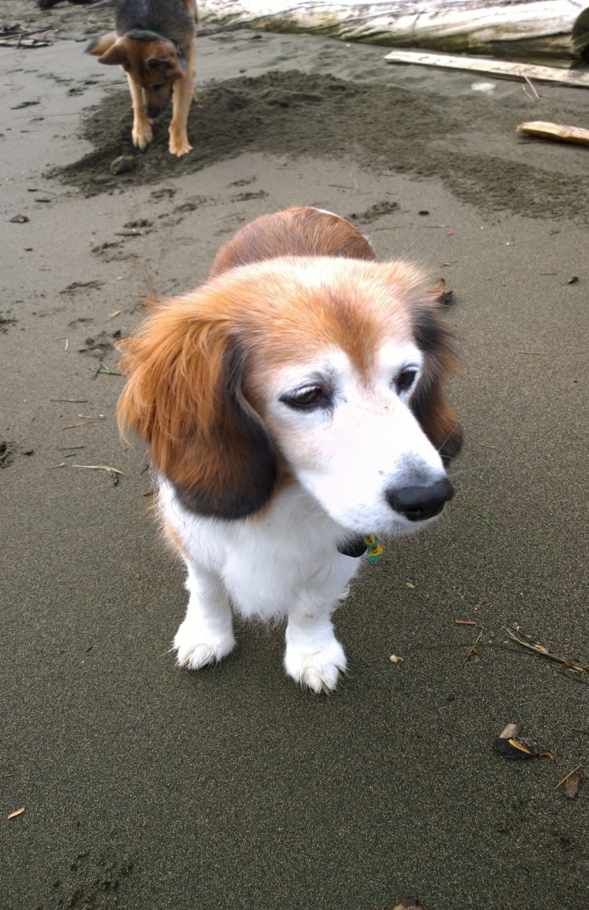
He is an aloof kind of guy .. totally adorable and draws lots of attention – “what type of dog is that?” He lived with our German Shepherd – Rookie. (Sadly, Rookie passed away a few years ago.)
Archie came to us with bad itchy skin, which we remedied with a new diet of no wheat, more seafood and at least 3 baths a week. We were going through a renovation and decided to put in a dog bath, just for Archie (not his favorite part of the house).

Archie has travelled quite a lot and he is always the perfect passenger.
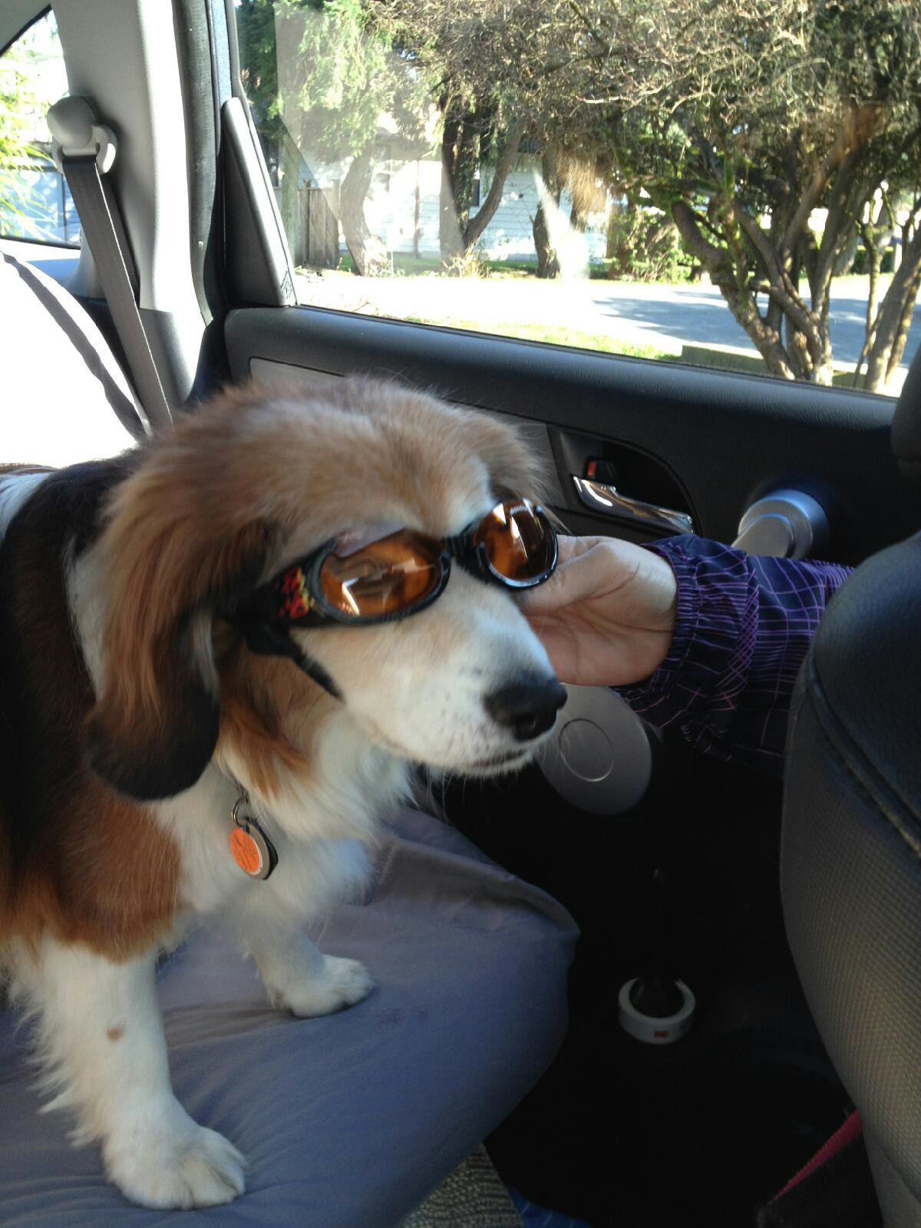

He loves his naps …
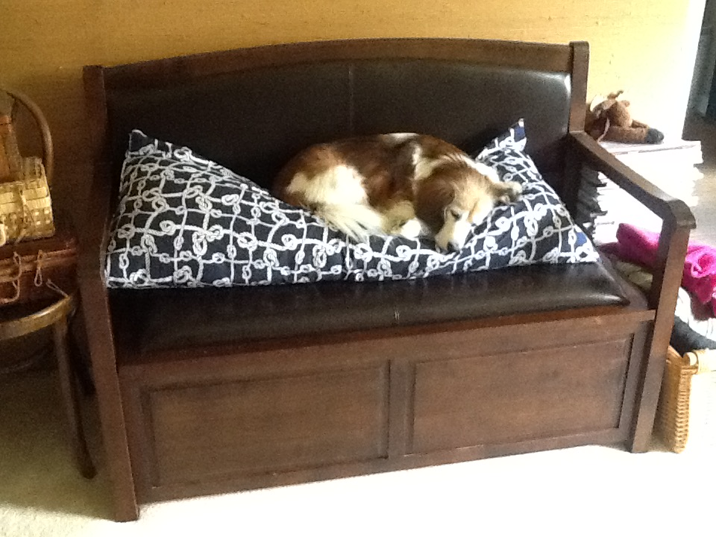

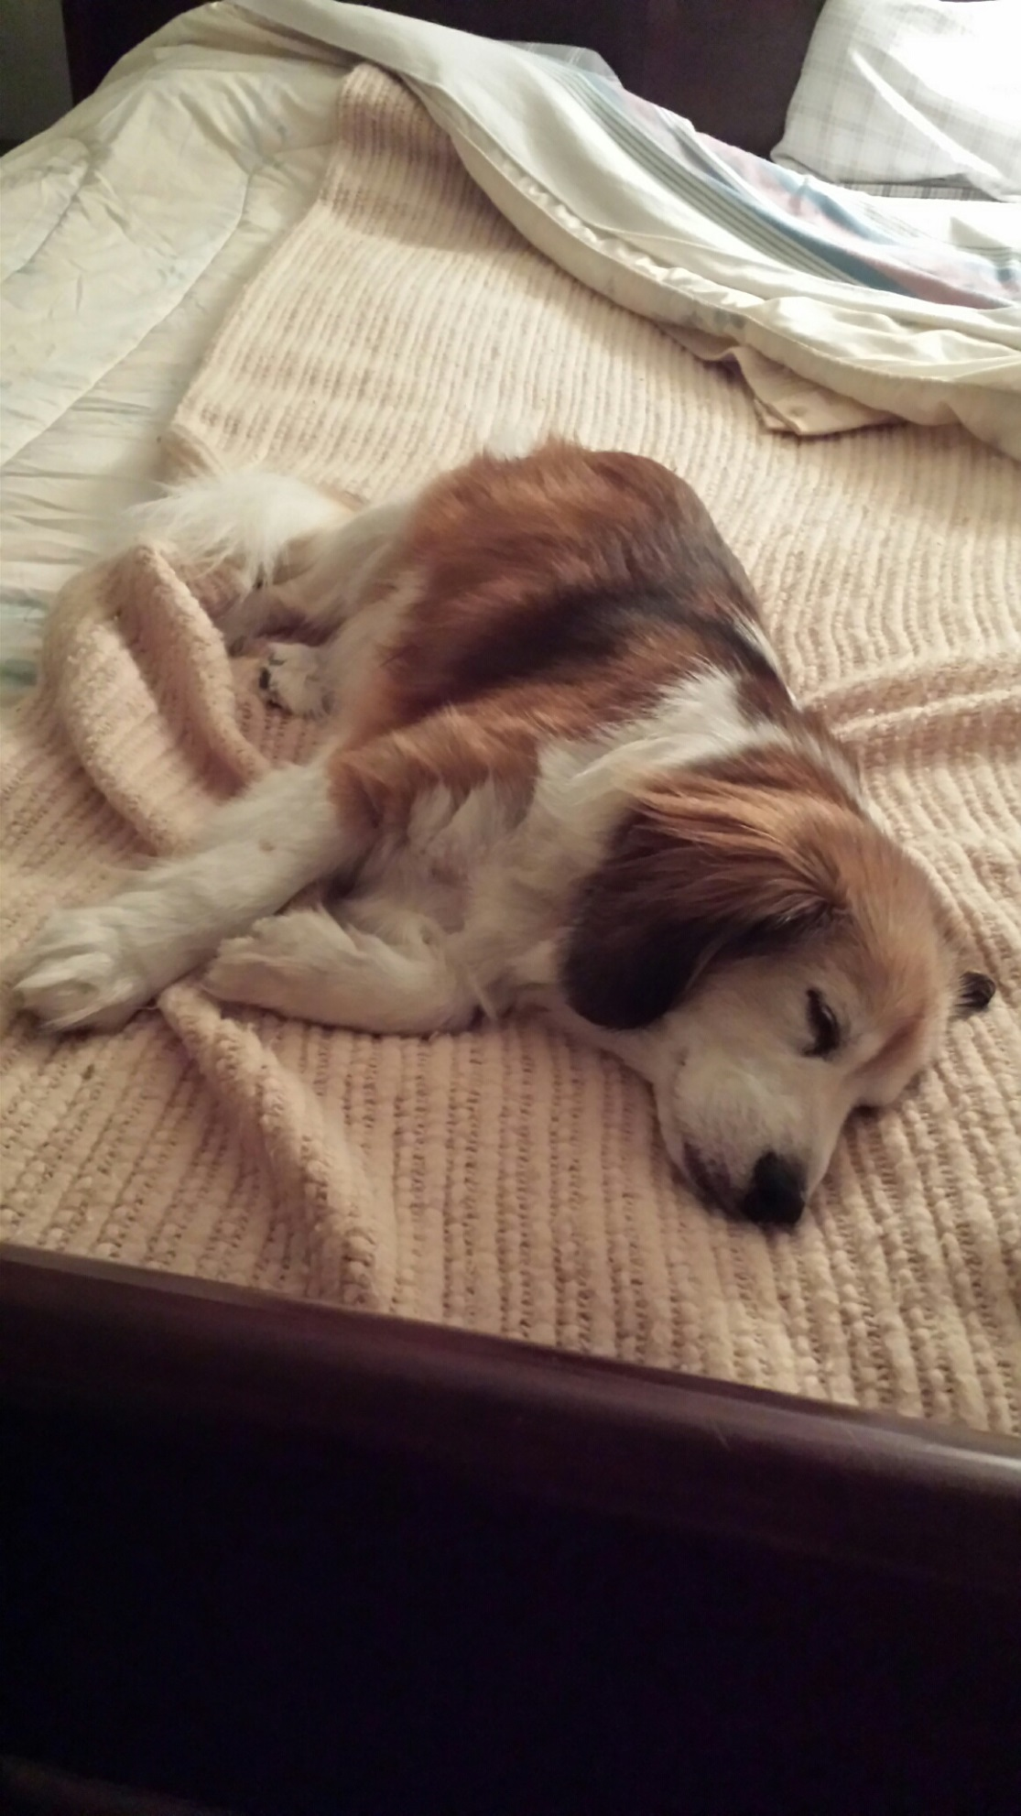
Archie goes to his cabin and loves exploring and chillin’.
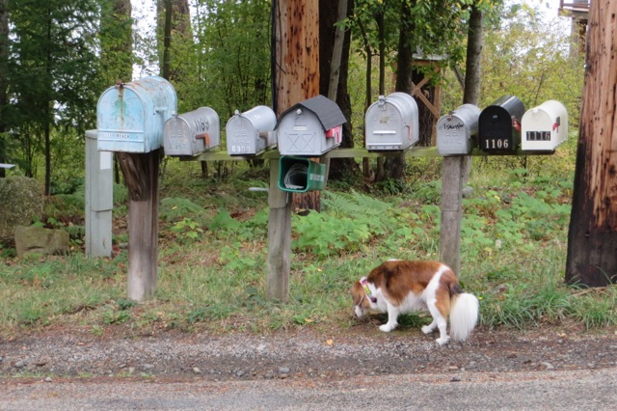
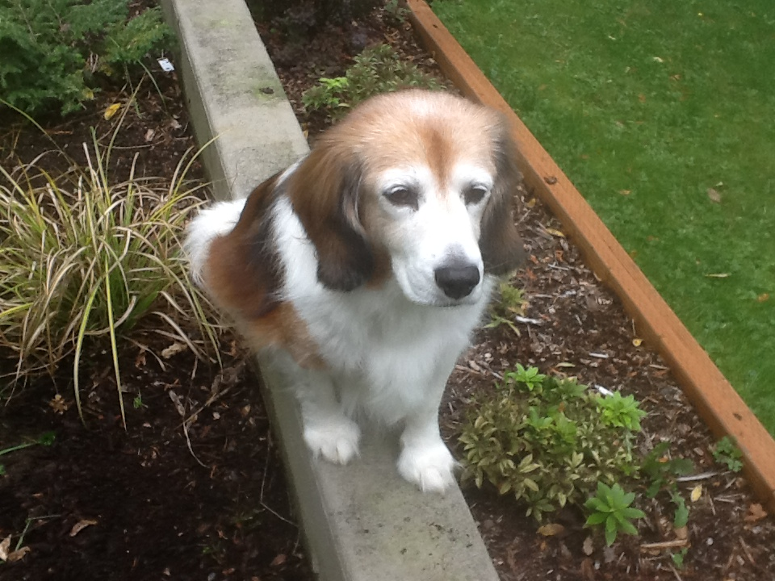

Archie participates on SPCA Walks .. and he LOVES the rabbit display.
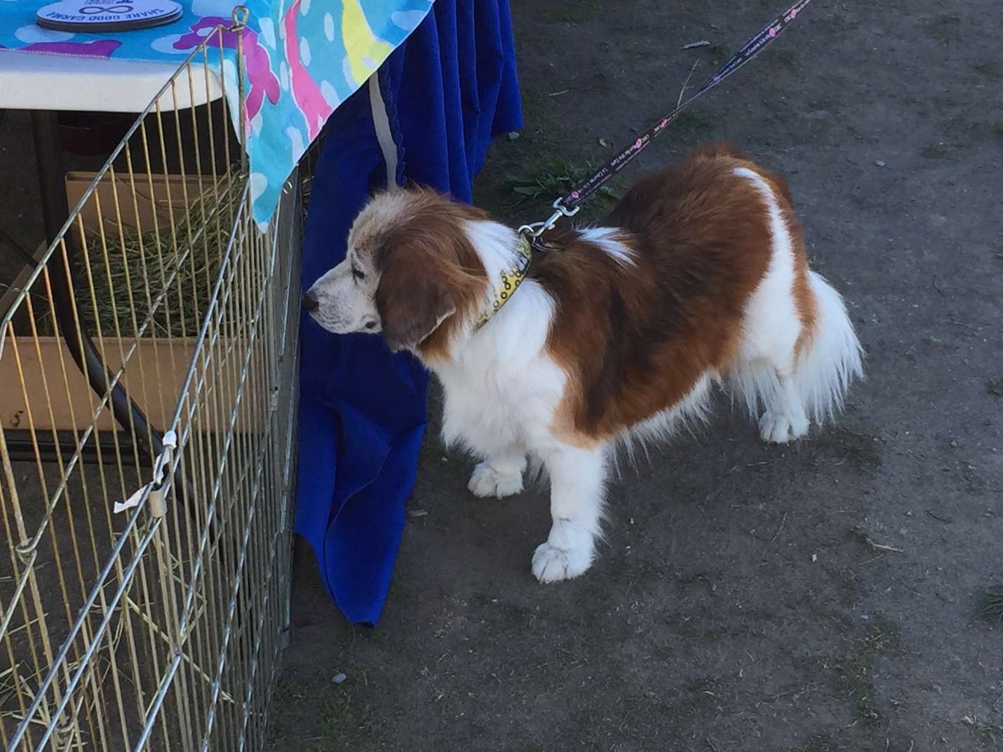

He also has friends .. (that is Rookie in the middle). 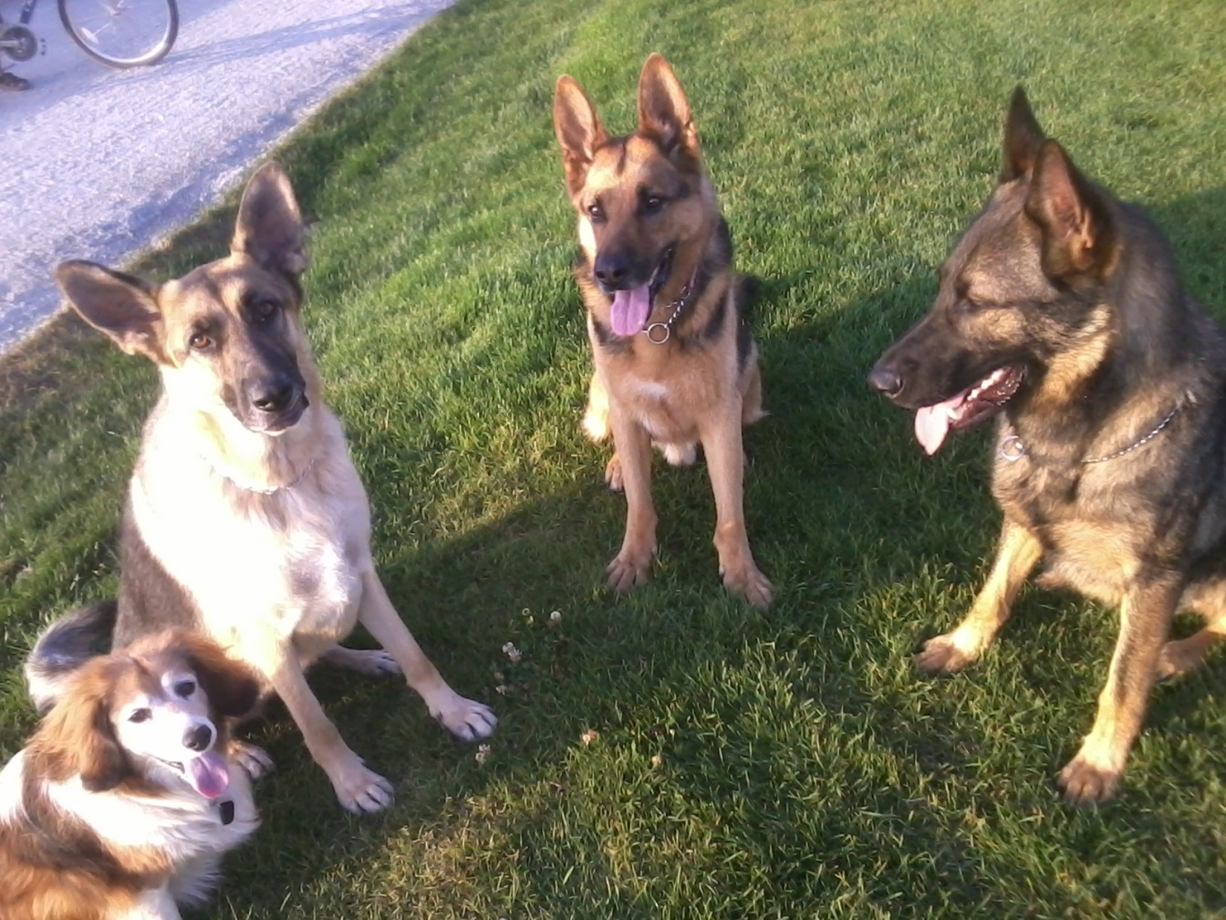
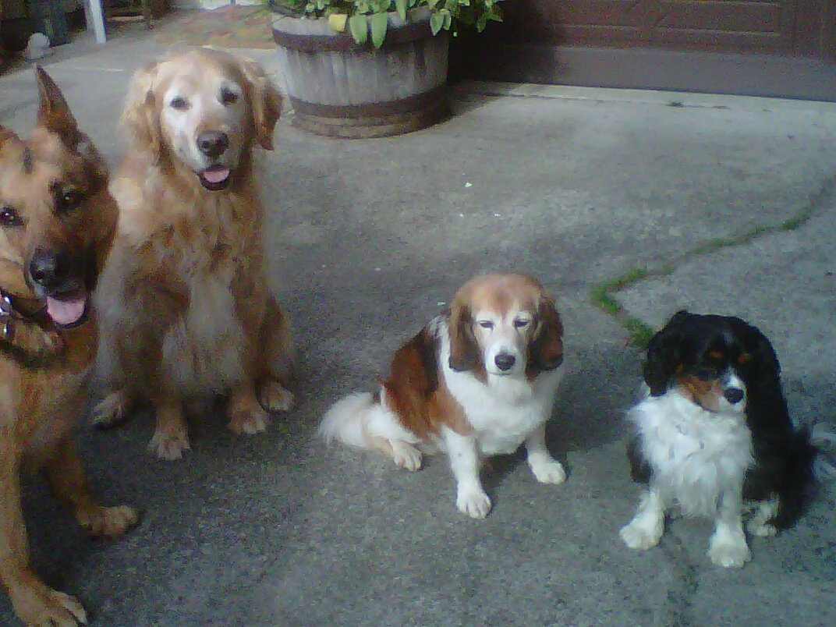

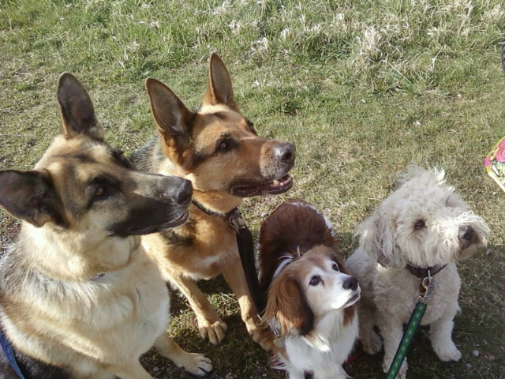

Archie now lives with his new sister Raina.
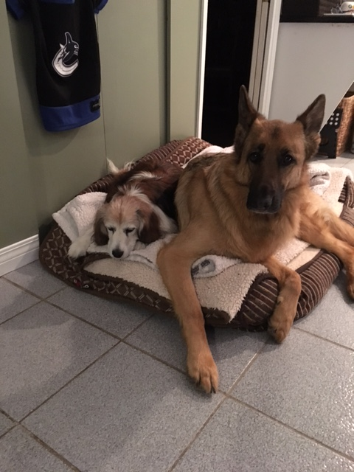
He is also a Seahawks fan …
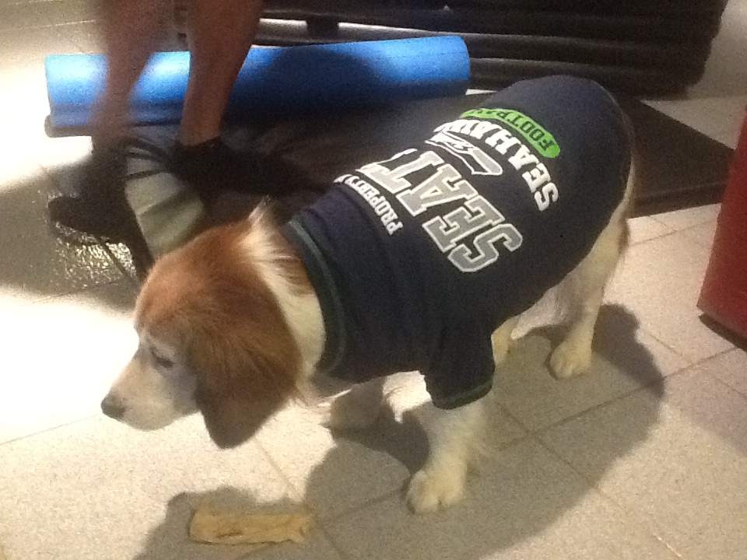

And .. he enjoys his visits at the local Starbucks.
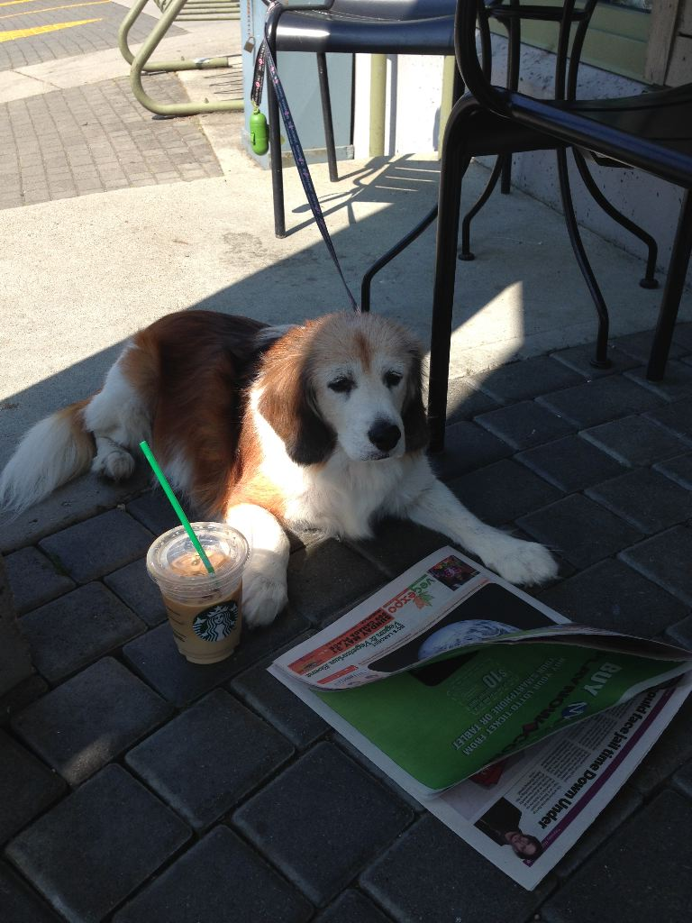

Archie is a wonderful sweet dog. He was diagnosed with leukemia two years ago and has since been on chemo. He receives his chemo every 2 weeks (pill form) and we are happy to report, he is in remission ! Nothing stops this little fella. We decided his birthday would be October 17, the day we adopted him, so that makes him around 15 years old.
This is Archie on a walk through the UBC Endowment Lands. He is a bit slower now but he still loves his life and food !
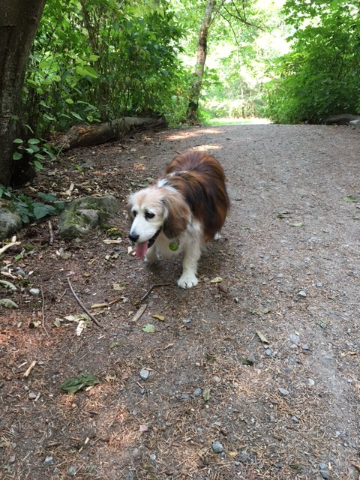
We thank Nina @ SPOT for letting us adopt our wonderful little boy.

